Coronary artery disease – Historical notes
Compiled by Dr. Stephen A Geller

2nd C – Galen performs may dissections, mostly on Barbary apes, and applies the name “coronary” because of the resemblance to a crown. Great physician and anatomist but he studied animal anatomy, influencing medicine for 14 centuries, until Vesalius.
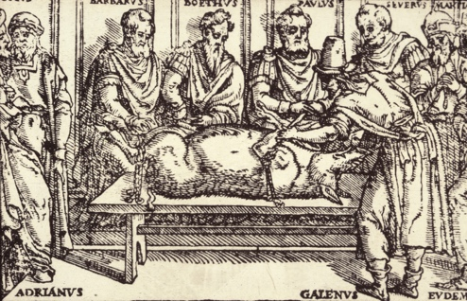
Galen demonstrating the recurrent laryngeal nerve in pig
1513 – Leonardo da Vinci (1452-1519) – drew anatomy of coronary arteries but inaccurately because of Galenic influence.
1543 – Andreas Vesalius (1514-1564) – one of the greatest figures in the history of medicine – University of Padua - performs many human dissections and overthrows more than 14 centuries of Galenic misinformation about human anatomy in his great book, “De Humani Corporis Fabrica” (The Structure of the Human Body) – accurate depiction of the coronary arteries.
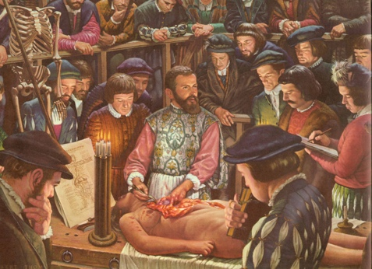
Robert Thom portrait of Vesalius
1628 – William Harvey (1578-1657) – one of the greatest figures in the history of medicine - studies medicine at the University of Padua – practices medicine in Folkestone, England, and correctly elucidates the function of the coronary arteries, based on physiologic and blood dilution studies as well anatomic observations – “father of physiology.”

Robert Thom portrait of Harvey
1761 – Giovanni Battista Morgagni (1682-1771) – one of the greatest figures in the history of medicine - at the University of Padua - establishes clinical-pathologic correlations, performing autopsies on most of his patients when they die, and observes morphologic changes in a case of angina pectoris.
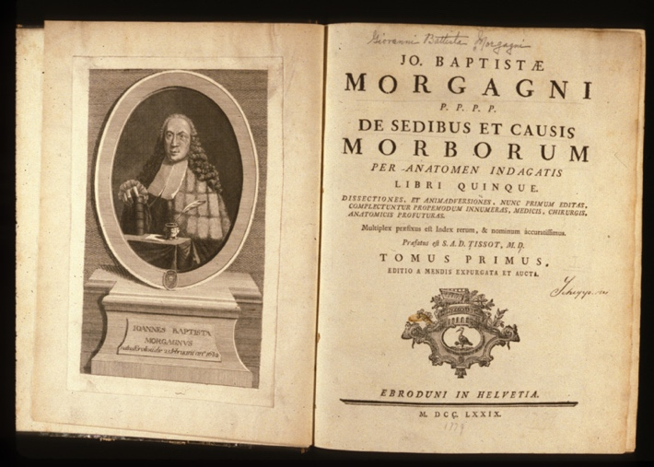
Morgagni and frontispiece of “De Sedibus …”
[Note: Three of the greatest physicians of all time – Vesalius, Harvey, Morgagni - were all connected to the University of Padua. Their monumental contributions were approximately a century apart.]

1768 – William Heberden (1710-1801) – describes 20 patients with angina pectoris but does not suspect cardiac etiology.
1772 – John Hunter (1728-1793) – great scientist, surgeon and anatomist - performs autopsy on Heberden’s patient who died after experiencing angina pectoris and suggests a link between the clinical manifestations and morphologic findings.
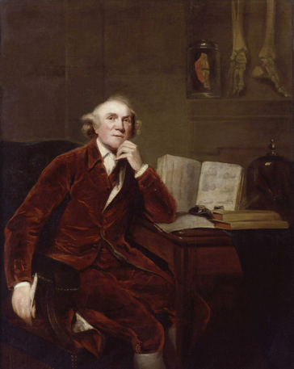
John Hunter by Joshua Reynolds
1777 – Edward Jenner (1749-1823) – creator of the smallpox vaccine – recognized angina pectoris in the great physician John Hunter, once his teacher, but does not report it to avoid alarming the great physician. Hunter described his own experience: “As I was walking about the room, I cast my eyes on a looking glass and observed my countenance pale, my lips white, and I had the appearance of a dead man looking at himself.”
1799 – Caleb H. Parry (1755-1822) – publishes report about angina pectoris, associating chest pain and heart involvement – Parry delayed publication to not alarm John Hunter.
1802 – William Heberden (1710-1801) – 8 years after Hunter’s death, again describes and names angina pectoris (“The termination is remarkable. The patients all suddenly fall down and perish almost immediately.”)
1880 – Carl Weigert (1845-1904) – describes changes of myocardial infarction at autopsy.
1912 – James Herrick (1861-1954) – classic description of myocardial infarction, including clinical and pathology features – identifies coronary thrombosis as principal etiology.
1947 – Arthur M. Master (1895-1973) – describes syndrome of coronary insufficiency – develops “Master’s two-step” exercise to elicit electrocardiographic changes of coronary artery disease.
1952 – Henry D. Moon (1914-1974) and James F. Rinehart (1901-1954) – observe aortic intima fragmentation in an infant and conclude this is earliest lesion.
1972 - William Roberts (1932-2023) – first Chief of Pathology at the NIH Heart, Lung and Blood Institute - concludes that most cases of myocardial infarction are not associated with coronary thrombosis.

