Atherosclerosis – Historical notes
Compiled by Dr. Stephen A Geller

Although typical changes of atherosclerosis have been demonstrated in Egyptian mummies, little of no mention of arteriosclerotic lesions can be found in the medical literature prior to the 17th century
1695 – Johann Conrad Brunner (1653-1727) – described classic findings of aortic atherosclerosis in his father-in-law, the great pathologist Johann Jakob Wepfer (16201695), noting that “the internal coat in several places was ruptured, lacerated and rotten like fruit, and hurt the fingers when thrust in it, from the roughness of the bones.”
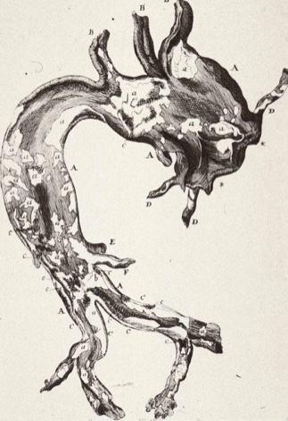
Wepfer’s aorta
1700 – William Cowper (1666-1709) – noted that the passage of blood was impeded in thickened arteries.
1755 – Albrecht von Haller (1708-1777) – wrote about gradual and progressive nature of atherosclerosis.
1761 - Frank Nicholls (1699-1788) – described dissecting (“incipient”) aortic aneurysm in the autopsy of King George II of England.
1761 - Giovanni Battista Morgagni – (1682-1771) – developer of the clinical-pathologic correlation and one of the greatest physicians in the history of medicine – emphasized and broadened the concept of vascular degeneration.
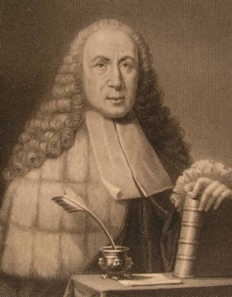
Morgagni
1801 – Marie-Francois Xavier Bichat (1771-1802) – known as the “father of histology” – recognized the intima as the site of the earliest lesions.
1804 – Antonio Scarpa (1752-1832) – studied aneurysms and suggested that ulcerated atheroma was the primary lesion.
1815 – Joseph Hodgson (1788-1869) – studied chemistry of the calcific plaque, identifying 65% as calcium phosphate and 35% as organic matter – also described lesions later known as Monkeberg’s calcific medial sclerosis.
1829 – Johann Friedrich Lobstein (1777-1835) – Professor Pathological Anatomy at Strasbourg (where first chair of Pathology was established) – refined morphologic and chemical studies and created term “arteriosclerosis.”
1842 – Carl Freiherr von Rokitansky (1804-1878) – founder of the great Vienna school of Pathology – considered arterial damage to be due to excess deposition of material from blood onto intima of arteries.
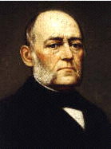
Rokitansky
1847 – Julius Vogel (1814-1880) – demonstrated cholesterol (then called “cholesterin”) in atheromatous plaques.
1858 – Rudolf Virchow (1821-1902) – one of the greatest physicians in the history of Medicine, often referred to as the “father of modern Pathology,” developed the “cell theory” – first detailed histologic studies of atherosclerosis.
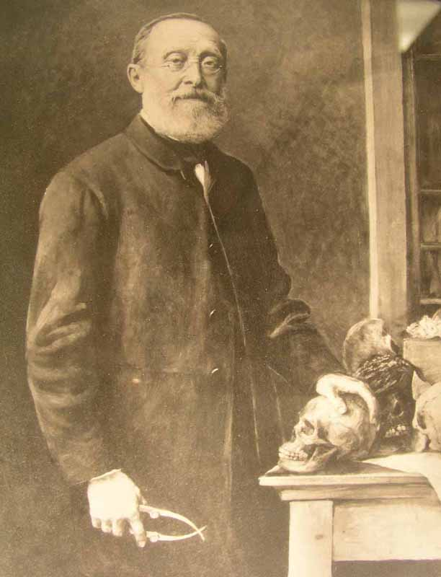
Rudolf Virchow photograph
1874 – Johann Otto Huebner (1843-1926) – differentiated syphilitic endarteritis (“Huebner’s endarteritis”) from other forms of arteriosclerosis.
1903 – Johann Georg Mönckeberg (1877-1925) – described aortic medial calcific sclerosis.
1904 – Felix Jacob Marchand (1846-1928) – proposed term “atherosclerosis” to cover all forms of arteriosclerosis.
1910 - Adolf Windaus (1876-1959) – provided quantitative proof linking cholesterol to heart disease, suggesting direct pathogenic role for lipids, confirmed two years later by Anitschow – awarded Nobel Prize in 1928 for his work on sterols – also discovered precursor molecule to vitamin D.
1912 – Nicolai Anitschkow (1885-1964) – produced typical atherosclerosis in rabbits after feeding them pure cholesterol dissolved in vegetable oil – establishing the lipid theory of pathogenesis – better known for his identification of the Anitschkow cardiac myocyte of rheumatic fever.

